9.18: The following table gives the revolutions and the angle through which the wheel has rotated for each instant in time and each of the three situations:

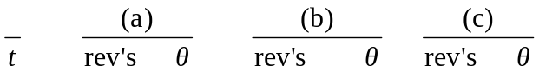

0.05 0.50 180 0.03 11.3 0.44 158

0.10 1.00 360 0.13 45 0.75 270

0.15 1.50 540 0.28 101 0.94 338

0.20 2.00 720 0.50 180 1.00 360
––––––––––––––––––––––––––––––––––––––

The and 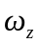graphs are as follows:

a)
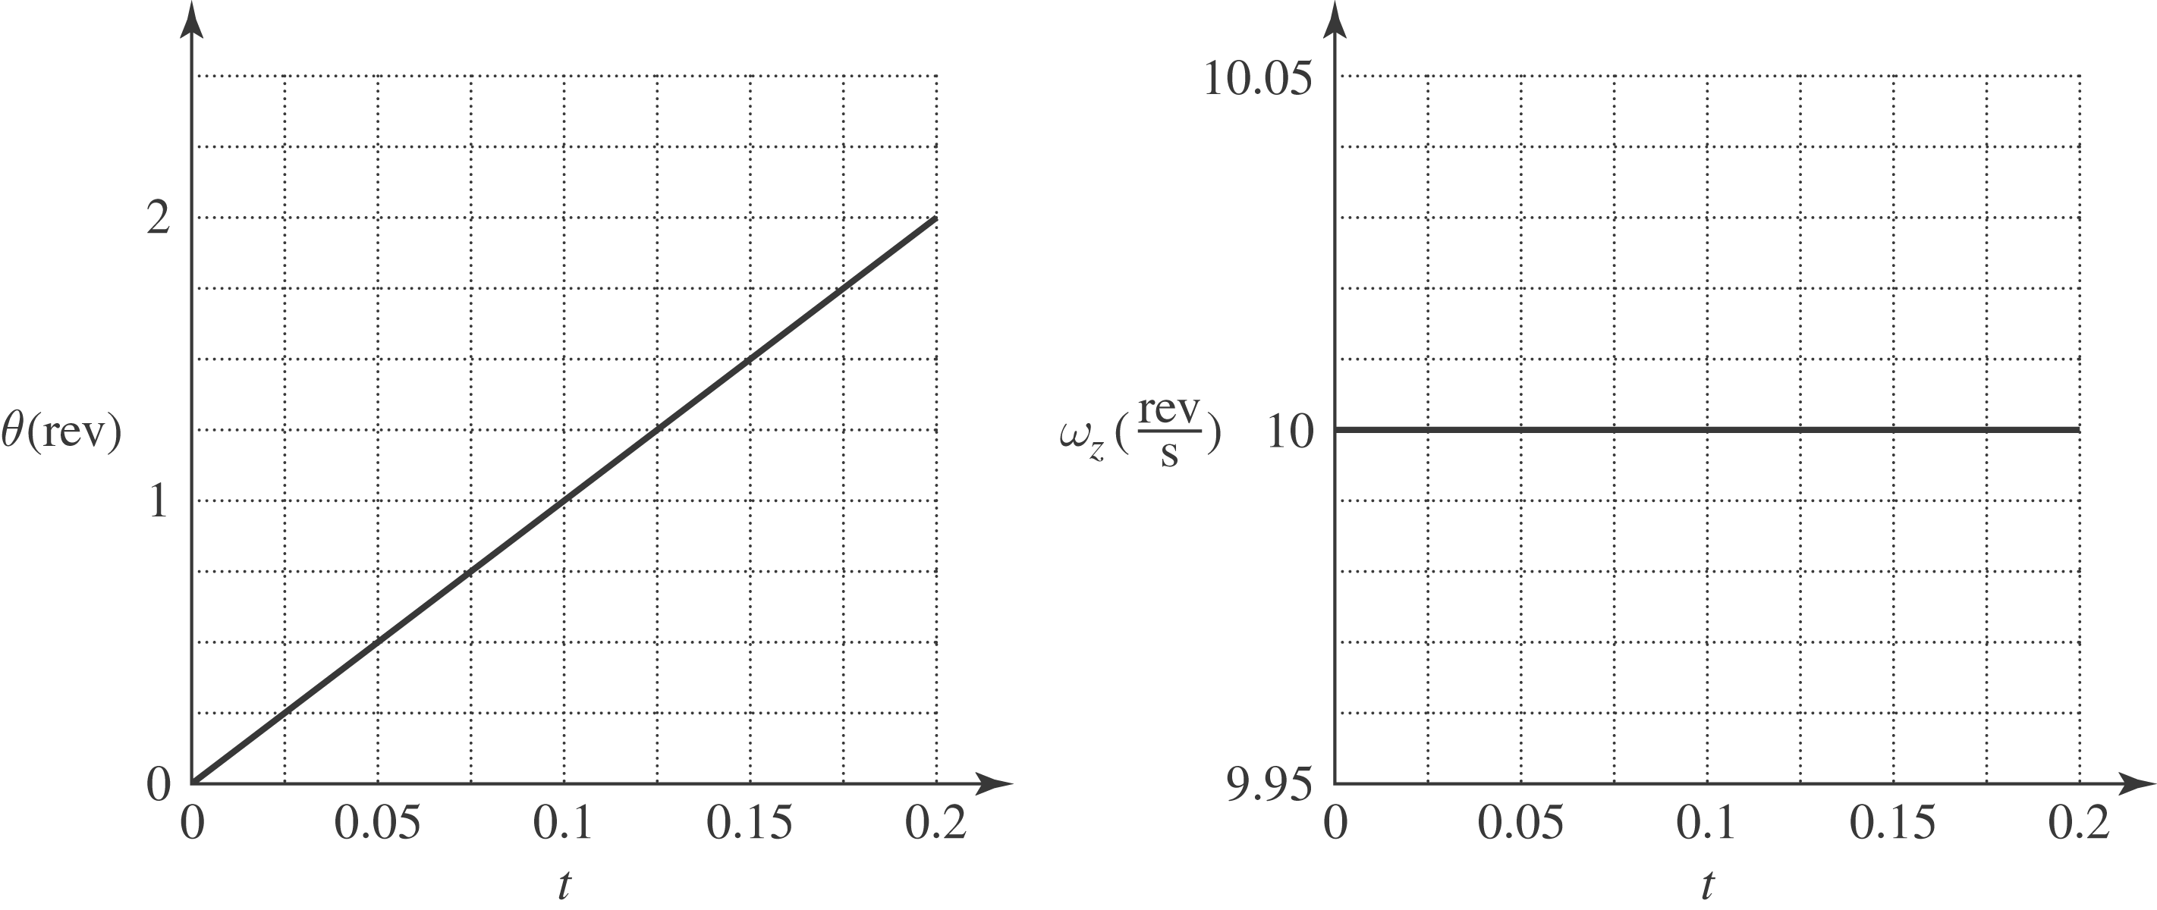

b)
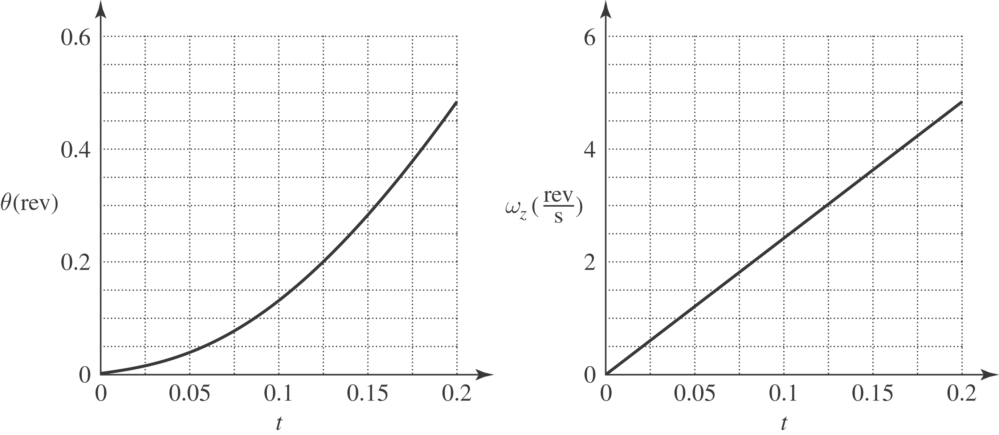

c)
